Certificate Generation and the Role of Certificate Authorities

Draven Chen
Department of Computer Science, Southern New Hampshire University
CS 305: Software Security
Professor Inshan Singh
September 26, 2026

Certificate Generation and the Role of Certificate Authorities
Transport Layer Security protects a connection in two distinct ways. It encrypts the traffic, and it proves to the client that the server on the other end is the server it intended to reach. Encryption alone is worth very little without that second guarantee: an attacker who successfully impersonates a bank's web server can establish a perfectly encrypted channel with the victim and read every credential that travels through it. The mechanism that closes this gap is the X.509 certificate, and the party that makes a certificate meaningful is the certificate authority (CA). This report explains the role and value of a CA, then documents the generation of a self-signed certificate using the Java Keytool utility for use in a development environment.
The Role and Value of a Certificate Authority
A certificate binds a public key to an identity. The server holds the matching private key and never discloses it; during the TLS handshake the server presents its certificate and proves possession of that private key by signing handshake data with it (Rescorla, 2018). The client can therefore confirm that whoever it is talking to controls the private key that corresponds to the public key in the certificate. What the client cannot confirm from the certificate alone is that the identity written inside it is genuine, because the server supplied the certificate. An attacker can generate a certificate that names a bank's domain just as easily as the real operator can.
A certificate authority resolves that problem by acting as a trusted third party. The CA validates that the applicant actually controls the domain named in the request, and it then signs the certificate with its own private key. Because the CA's root certificate is already embedded in the trust stores shipped with operating systems and browsers, the client verifies the CA's signature using a public key it obtained through a channel it already trusts, rather than from the server under evaluation. Verification proceeds up a chain from the server certificate through any intermediate certificates to a trusted root, and the client checks the signature, the validity dates, the name constraints, and the revocation status at each link (Cooper et al., 2008). Trust is transferred, not assumed.
Why Use a Certificate Authority for Security?
The practical answer is that a CA is the only party in the exchange with no incentive to lie and no ability to be impersonated by the attacker. The security of the entire handshake rests on the client being able to anchor its trust somewhere outside the connection it is trying to evaluate. Without an external anchor, a machine-in-the-middle attack is undetectable: the attacker terminates the client's TLS session, presents a self-issued certificate, opens a second session to the legitimate server, and relays traffic while reading it in the clear. A CA-issued certificate defeats this because the attacker cannot obtain a valid signature for a domain it does not control.
A CA also supplies the operational machinery that makes a public key infrastructure trustworthy over time. It performs domain and organizational validation before issuance, it publishes revocation information through certificate revocation lists and the Online Certificate Status Protocol so that a compromised key can be repudiated before the certificate expires, it logs issuance to public Certificate Transparency logs so that mis-issuance can be detected, and it protects its own signing keys in hardened, audited facilities (Barker, 2020; CA/Browser Forum, 2024). A developer generating certificates on a laptop provides none of these services.
Advantages of Using a Certificate Authority
Using a CA produces several concrete advantages. The first is universal client trust: browsers, mobile operating systems, and language runtimes accept the certificate with no configuration, so no user is ever trained to click through a security warning. The second is verified identity, since the CA confirms domain control and, for organization-validated and extended-validation certificates, the legal existence of the organization named in the subject field. The third is revocation, which is the ability to invalidate a certificate immediately after a key compromise rather than waiting for it to expire. The fourth is accountability, because publicly trusted CAs operate under the CA/Browser Forum Baseline Requirements, submit to annual audits, and can themselves be distrusted by browser vendors if they mis-issue. The fifth is lifecycle automation, since modern CAs support automated issuance and renewal through the ACME protocol, which matters because the industry has steadily shortened the maximum certificate lifetime and manual renewal no longer scales. The sixth is commercial support, as paid CAs back their issuance with warranty and incident response.
The counterweight is cost and prerequisite. A publicly trusted certificate requires a registered domain name the applicant can demonstrate control over, and depending on the validation level it may carry a recurring fee. In a development or laboratory environment neither the domain nor the fee is justified, because there are no external users whose trust decisions are at stake. In that situation the developer becomes the CA and issues a self-signed certificate. The cryptography is identical, the key sizes and signature algorithms are the same, and the HTTPS listener behaves the same way; the only thing missing is third-party attestation, which is precisely the part that has no audience on a local machine. A self-signed certificate is appropriate for development and internal testing and inappropriate for production.
Certificate Generation With the Java Keytool
The certificate for this assignment was generated with keytool, the key and certificate management utility bundled with the Java Development Kit (Oracle, n.d.). Three commands were used. The first generates a 2,048-bit RSA key pair, wraps the public key in a self-signed X.509 certificate valid for 360 days, and stores both in a new keystore under the alias selfsigned:

keytool.exe -genkey -keyalg RSA -alias selfsigned
-keypass password -keystore keystore.jks -storepass password
-validity 360 -keysize 2048

Because no distinguished name is supplied on the command line, keytool prompts interactively for the subject fields. The values entered were CN=localhost, OU=Software Security, O=Artemis Financial, L=Manchester, ST=NH, and C=US. The common name localhost is deliberate: it is the host name the development server is reached by, and a client rejects a certificate whose common name does not match the requested host even when the signature itself is valid. Figure 1 shows the completed form.

Figure 1
Keytool distinguished-name prompts with all subject fields completed
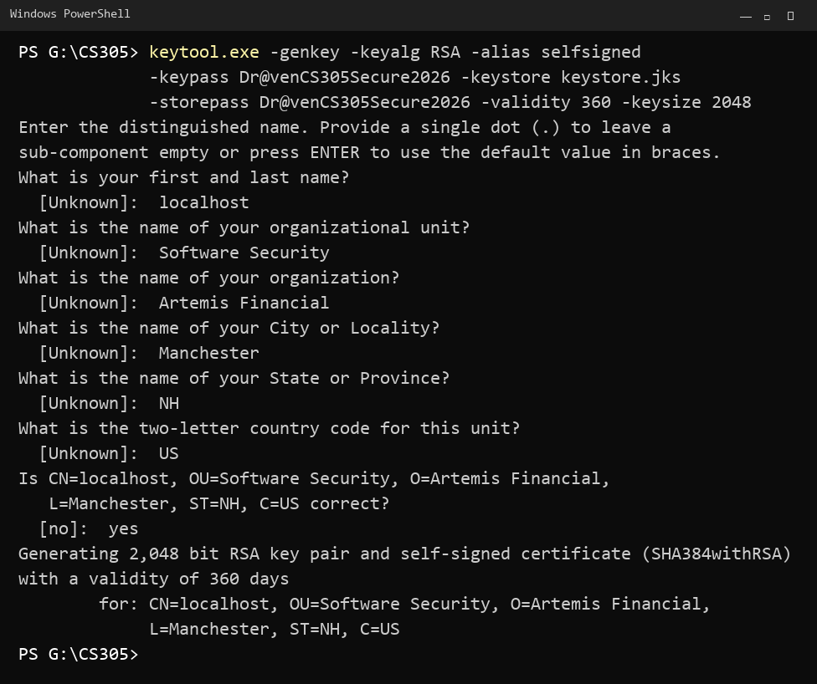

The second command exports the certificate, which is the public half of the pair, out of the keystore and into a standalone CER file that can be distributed to clients:

keytool.exe -export -alias selfsigned -storepass password
-file server.cer -keystore keystore.jks

The third command reads that file back and prints its contents, which confirms the certificate was written correctly and shows exactly what a client would evaluate:

keytool.exe -printcert -file server.cer

The export confirmation and the printed output, shown together in Figure 2, confirm that generation succeeded. The owner and issuer distinguished names are identical, which is the defining signature of a self-signed certificate and the field a client inspects to determine that no external authority vouched for it. The output also reports the serial number, the 360-day validity window, the SHA-1 and SHA-256 fingerprints a user could verify out of band, the signature algorithm, the 2,048-bit RSA subject public key, the X.509 version 3 format, and the subject key identifier extension.

Figure 2
Export of the certificate to server.cer and the resulting keytool -printcert output
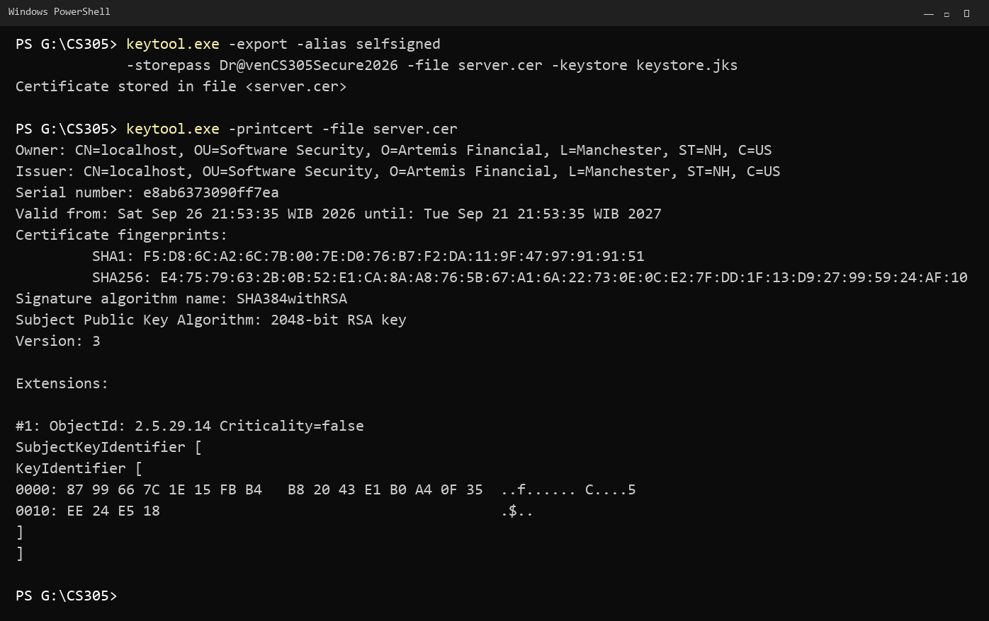

One detail is worth noting for anyone reproducing this on a current release of the JDK. Keystores now default to the PKCS12 format rather than the older proprietary JKS format, and PKCS12 does not support a key password that differs from the store password. If the two values are not identical, keytool prints a warning and ignores the -keypass value, so supplying the same password for both avoids the warning entirely. The key pair generated here was signed with SHA384withRSA, which is the current default for a 2,048-bit RSA key and is stronger than the SHA256withRSA shown in the assignment example.
Conclusion
A certificate authority converts a public key into a statement a stranger can rely on. It validates identity before issuance, signs with a key already trusted by every mainstream client, and maintains the revocation and transparency infrastructure that lets a compromised certificate be withdrawn and a mis-issuing authority be caught. Those services are what a production system pays for. In development, where no third party needs to be convinced, a self-signed certificate generated with keytool provides the same cryptographic protection at no cost, and it is the certificate that will enable HTTPS for the Artemis Financial application in Project Two.

References
Barker, E. (2020). Recommendation for key management: Part 1 – General (NIST Special Publication 800-57 Part 1, Rev. 5). National Institute of Standards and Technology. https://doi.org/10.6028/NIST.SP.800-57pt1r5
CA/Browser Forum. (2024). Baseline requirements for the issuance and management of publicly-trusted TLS server certificates. https://cabforum.org/working-groups/server/baseline-requirements/documents/
Cooper, D., Santesson, S., Farrell, S., Boeyen, S., Housley, R., & Polk, W. (2008). Internet X.509 public key infrastructure certificate and certificate revocation list (CRL) profile (RFC 5280). Internet Engineering Task Force. https://doi.org/10.17487/RFC5280
Oracle. (n.d.). keytool: Key and certificate management tool. In Java Platform, Standard Edition tools reference. Retrieved September 26, 2026, from https://docs.oracle.com/en/java/javase/21/docs/specs/man/keytool.html
Rescorla, E. (2018). The Transport Layer Security (TLS) protocol version 1.3 (RFC 8446). Internet Engineering Task Force. https://doi.org/10.17487/RFC8446

